# Assignment No 3

## Question No 5

If a car agency sells 50% of its inventory of a certain foreign car equipped with side airbags, find a formula for the probability distribution of the number of cars with side airbags among the next 4 cars sold by the agency.

Ans: Binomial Distribution.

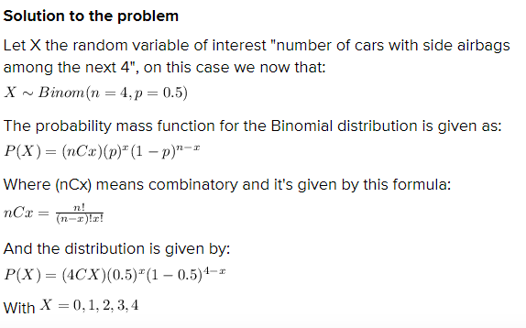

## Question no 1

<https://cecs.wright.edu/~gdong/mining03/tuto1/lesson_5.html>

In a certain assembly plant, three machines, B1, B2, and B3, make 30%, 45%, and 25%, respectively, of the products. It is known from past experience that 2%, 3%, and 2% of the products made by each machine, respectively, are defective. Now, suppose that a finished product is randomly selected. If a product was chosen randomly and found to be defective, what is the probability that it was made by machine B3?

## Question No 2

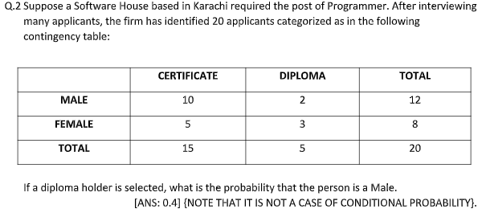

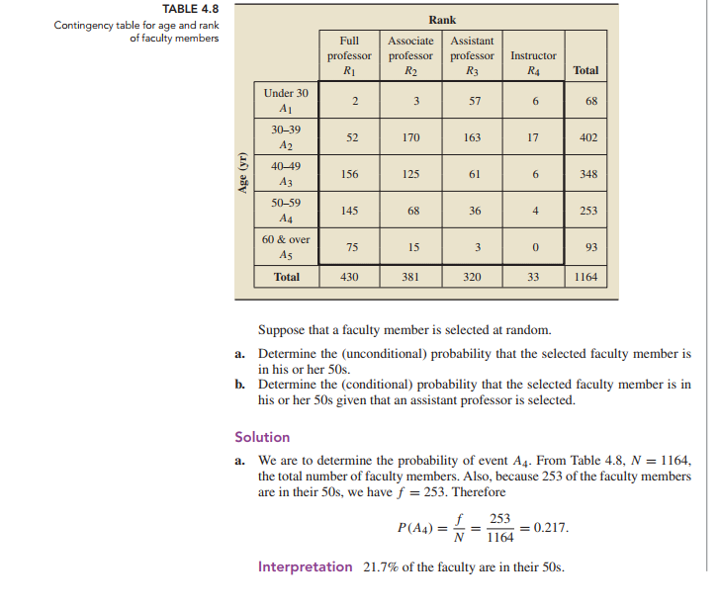

## Question no 3

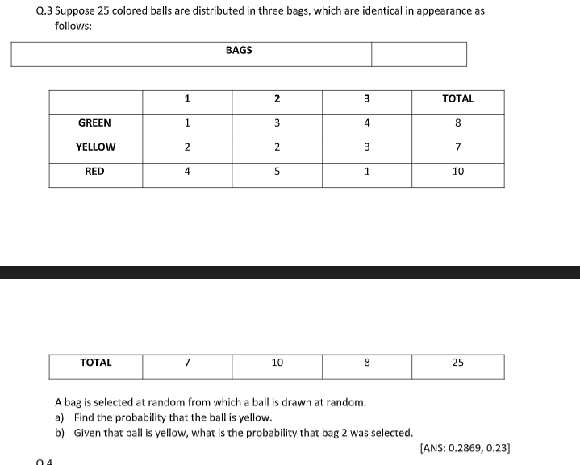

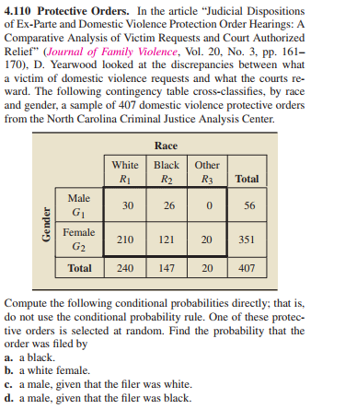

PG 178